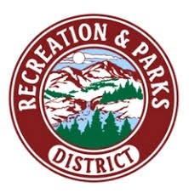
Survey for Organizations Representing Individuals with Disabilities

Name of organization _____________________________________________
Optional:
Name of person completing form ____________________________________

Address _______________________________ Contact person _________________________

_______________________________ Position _______________________________

Phone ________________________________ Today’s date ___________________________
Email _________________________________
Please complete the survey regarding programs, services and resources your organization provides for persons with disabilities in the Mount Shasta Recreation and Parks District area. Your input will assist the Mount Shasta Recreation and Parks District to identify available resources and priorities for accessibility.

- What direct communications have you had with the District regarding services and accommodations for individuals with disabilities?

____________________________________________________________________________

- Are you aware of any specific complaints or problems regarding access for individuals with disabilities to any of the programs, services, activities or events provided by the District?

____________________________________________________________________________

- What information or other resources can you supply to help educate or inform the District about your organization and your services for individuals with disabilities?

____________________________________________________________________________

- What general guidance, advice or assistance could your organization provide to the District to protect against potential discrimination of individuals with disabilities in its programs, services, activities and events?

____________________________________________________________________________

- What do you feel is the highest priority for the District to improve accessibility for individuals with disabilities?

____________________________________________________________________________

Please return this survey by May 6, 2022 to Shannon Shaw, ADA/504 Coordinator, Mount Shasta Recreation and Parks District, 1315 Nixon Road, Mt. Shasta, CA 96067.

For any additional feedback, please contact Shannon Shaw by phone at (530) 926-2494, by TDD through California Relay at 7-1-1, or by email at shannon@msrec.org.

Thank you for your input

